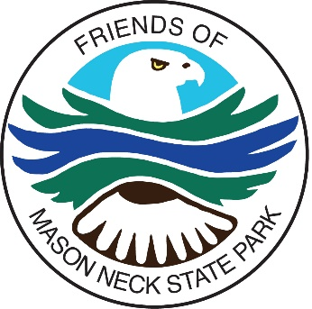
July 2023 Newsletter

Fairfax Master Naturalists Adopt the Park’s Pollinator Gardens as a Chapter Project

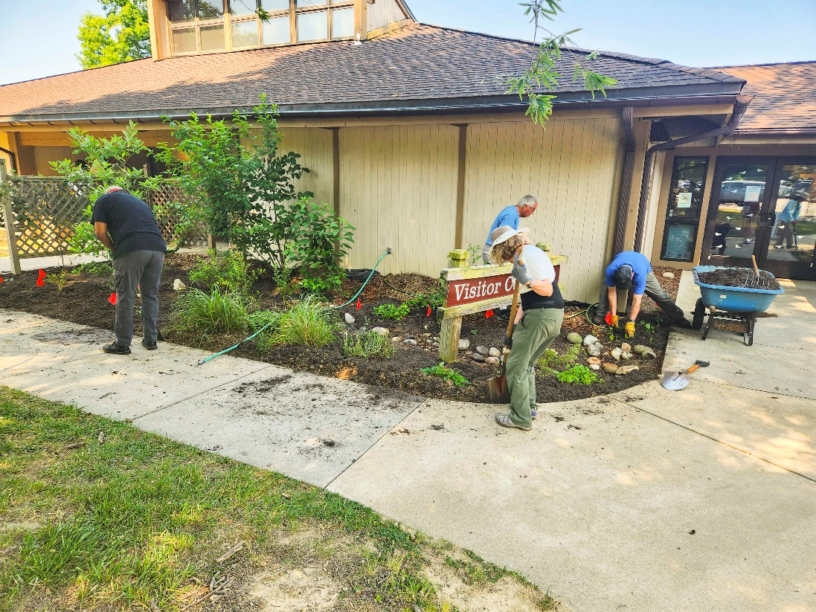
Photo by Pam Cressey

Have you noticed the big improvements in the pollinator garden in front of the Visitor Center? The Fairfax Master Naturalists have adopted the park’s pollinator gardens as a chapter project. The Friends of Mason Neck State Park have been gardening and watering the gardens, but we needed more help. Now the Friends and the Fairfax Master Naturalists are hard at work, removing weeds, adding plants, placing mulch, and watering the gardens. Thank you to the Fairfax Master Naturalists, the Friends, and other volunteers who are helping to make the park beautiful and attractive to wildlife.

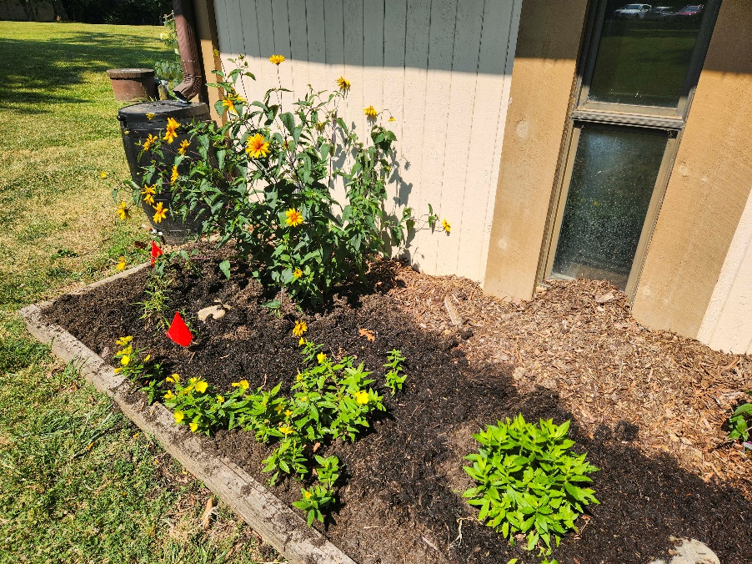
Photo by Pam Cressey
Watering the plants has always been a problem. Local resident Paul Thieberger, President of K&B Plumbing, helped by donating and installing a water faucet at the front of the Visitor Center, making the job much easier. He also installed an outdoor water bottle filling station at the Visitor Center. Thanks, Paul!

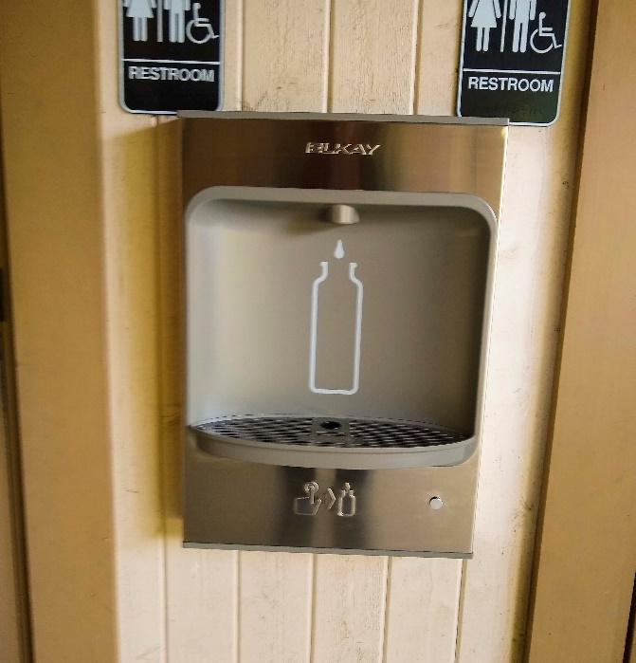

Would you like to help make the pollinator gardens even better? Workdays are scheduled every two weeks from now through November. You can sign up to help here.

“Picture the Magic” Photography Contest Opens for Submissions July 15, 2023

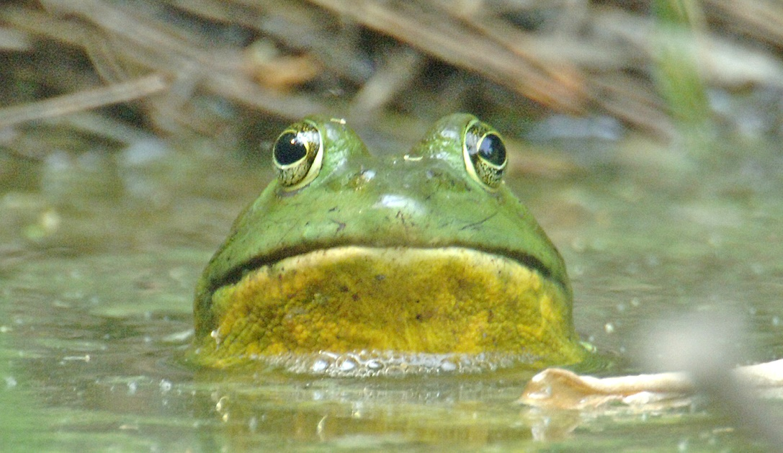
Photo by Randy Streufert

It’s time to start taking pictures for the Friends’ photo contest. We are again looking for images that capture the magic of the park. There will be a 1st prize winner ($200) for youth (ages under 18), a 1st prize winner ($200) for adults (ages 18 and up), and a grand prize winner ($300).

Images must be in one of these three categories:

- Park Staff in Action – images showing uniformed Mason Neck State Park staff interacting with the public, performing park maintenance, or other official duties.
- Flora and Fauna – images taken in the park of native plants and animals.
- Aquatic activities – images showing people enjoying Belmont Bay or Kane’s Creek in kayaks, canoes, or other non-powered water vessels.
Each photographer may submit up to three images. However, for any image to be considered, the photographer must submit at least one image in the “Park Staff in Action” category.
All images must have been taken inside the boundaries of the park or within 100 yards of the shore and, at any time in 2022 or 2023.
The contest will be open for submissions from July 15 to September 30, 2023.
The submission form and contest rules will be available on the Friends website on July 15. You can find the website here.

Osprey Chicks Hatch
Near the Visitor Center
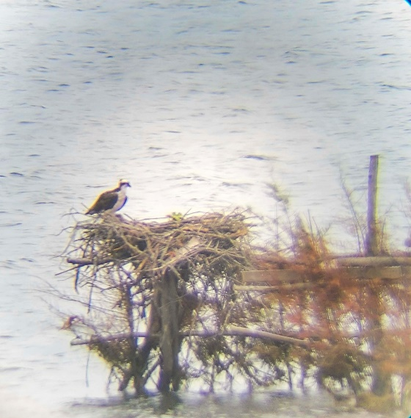
Photo by Jamie Leeuwrik

The pair of Ospreys that built a nest at the duck blind near the Visitor Center “celebrated” the hatching of two chicks recently. The chicks are too small be visible above the edge of the nest right now, but you can at least get a view of an adult standing guard over the nest from the Visitor Center. They will quickly grow to full size, with 5- to 6-foot wingspans.
The young birds will stay in the nest for 50 to 55 days before they fledge, or leave the nest, so see if you can spot them the next time you visit the park. After they fledge, they’ll stay in the vicinity while the parents feed them as they learn to fish for themselves. They’ll migrate south in October.

Chick O’Dee Answers Your Mason Neck State Park Critter Questions

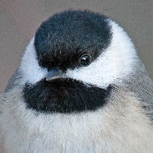
Photos and story by Randy Streufert

Twelve-year old Stephen recently asked: There are birds I often hear in the summer at the park, but they are up in the trees and I’m lucky to get a glimpse of them before they disappear behind all the leaves. Are they afraid to be seen and what might they be?

Chick O’Dee replies: Stephen, those are two great questions!
This area hosts a variety of birds that migrate from Central and South America in the spring. Some species stay for a few weeks then continue their migration to northern states and even Canada. Others remain for the summer to nest and raise a brood of chicks.

Most of these birds eat insects. The insects they like are most often found high up in the branches and leaves of trees. Unless the birds need to come down to drink, they tend to stay where their food is.

So, the answer to your first question is no, they are not hiding, but are just very hard to see through all those leaves. If they really wanted to hide, you wouldn’t hear them singing.

To answer your second question, there are too many potential species to list that fit the category of “heard but not seen” but many are likely warblers and vireos. Here are some images of a few of them you might hear at the park this summer.

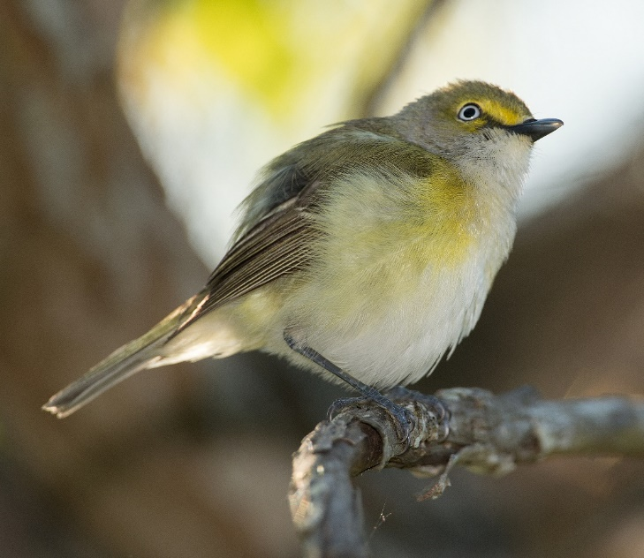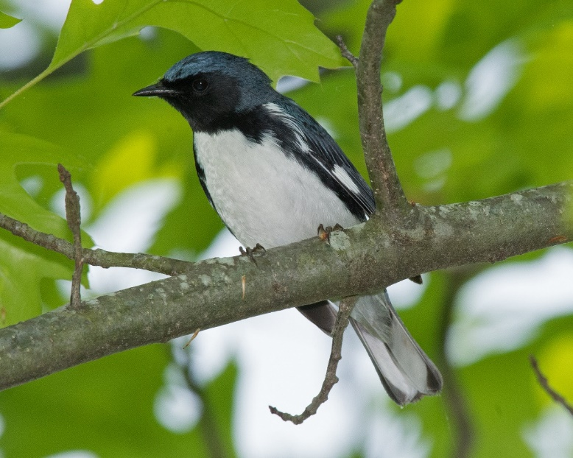
White-eyed Vireo Black-throated Blue Warbler

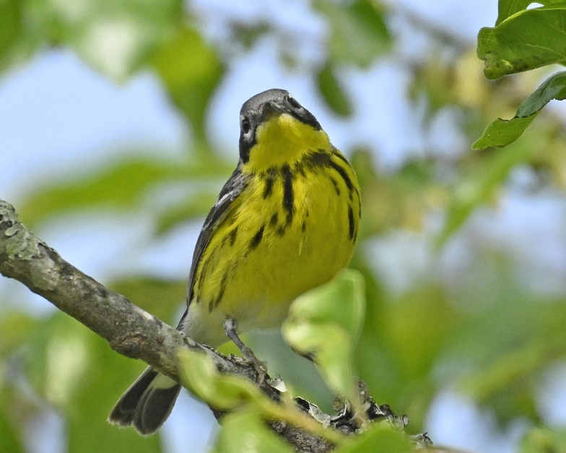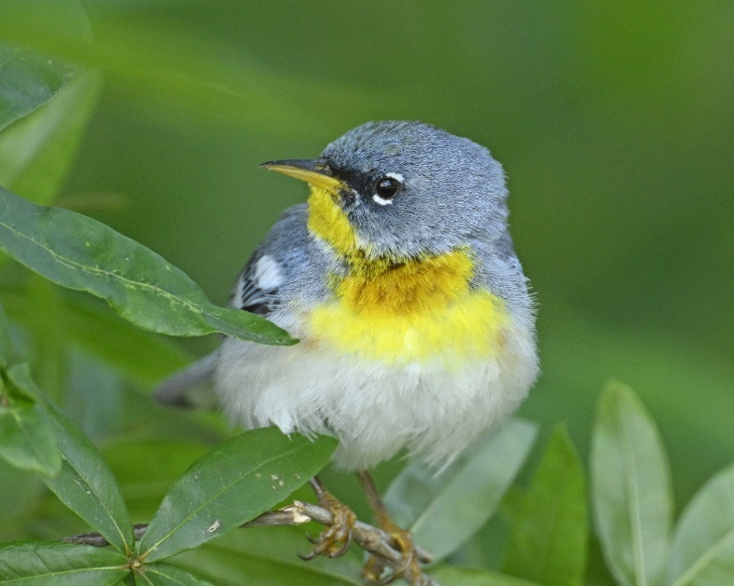
Magnolia Warbler Northern Parula

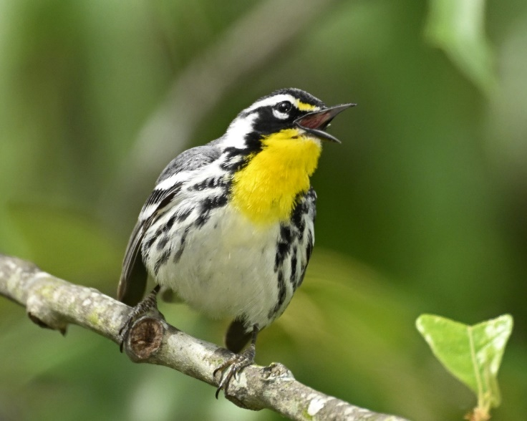
Yellow-throated Warbler

If you want to know what bird you are hearing but can’t see it, there are apps for smartphones that can detect and identify the bird. A popular one is Merlin by the Cornell Lab of Ornithology. You can learn about and download Merlin here. You can find several other bird id apps on the internet as well.

Have a question for Chick? To send in your inquiry, use the “Contact Us” tab on the homepage of the Friends website. We’ll do our best to answer it in our next newsletter.

The Friends of Mason Neck State Park Board of Directors
Is Seeking Advisors

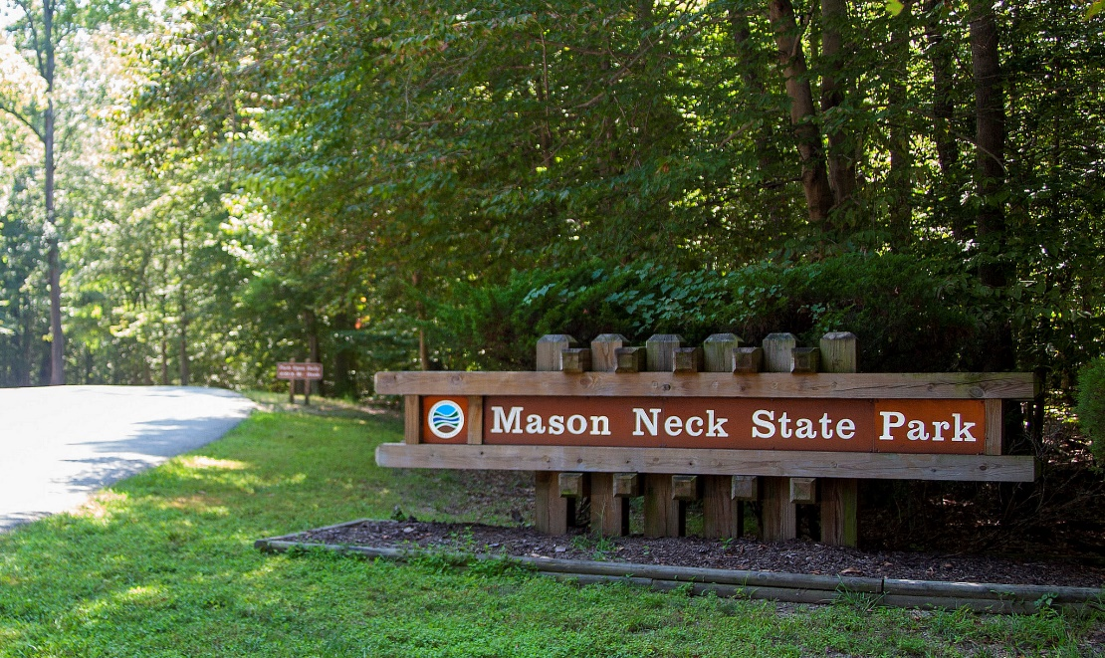

The Board of the Friends of Mason Neck State Park works hard to fulfill the Friends’ mission of identifying and promoting activities to conserve, enhance, and interpret the natural, educational, recreational, cultural, and historic resources of the park. However, we feel we need more input from the community to ensure that we are fully considering the needs and interests of the people who use the park. Would you like to help by serving on an advisory committee that would meet to discuss the park and the Friends’ role in supporting it? We’d like the committee to represent all the park’s visitors, including younger people, people of color, different nationalities, and underserved communities in the area. Please email the Friends’ President, Hillary Clawson, at hillary.k.clawson@gmail.com if you’d like to join the advisory committee or learn more about this opportunity.
History Day at
Mason Neck State Park

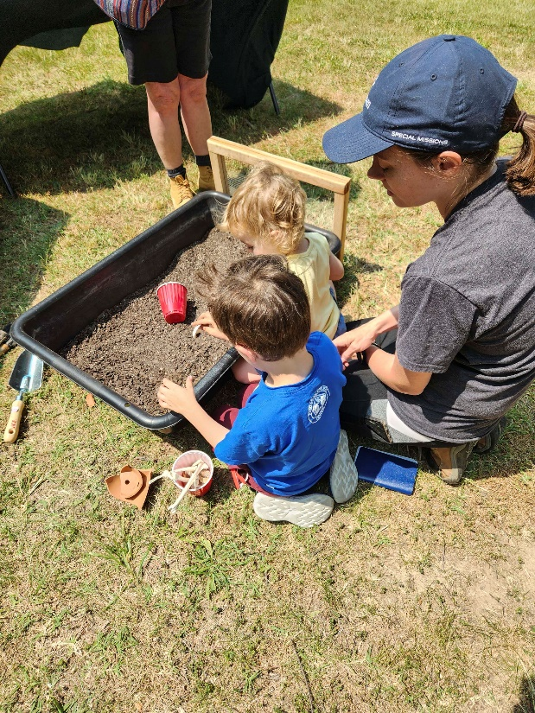

Each year, all Virginia State Parks commemorate the founding of the Virginia State Parks system on June 15, 1936, with a History and Culture Day. This year, the park Staff and the Friends of Mason Neck held the “Dig It Up’ archaeology program to provide a hands-on opportunity to learn archaeological skills and learn about the material cultures of Indigenous peoples like the Moyumpsee, or Doeg, who inhabited the Mason Neck peninsula.

The young explorers used brushes to examine the bins and discover pottery, stone points and bones.

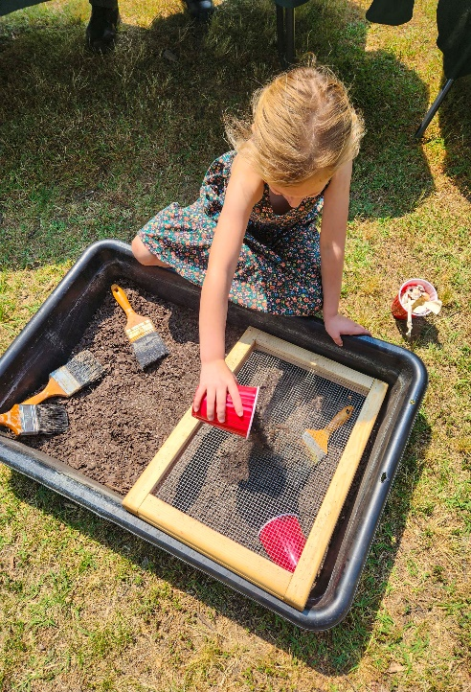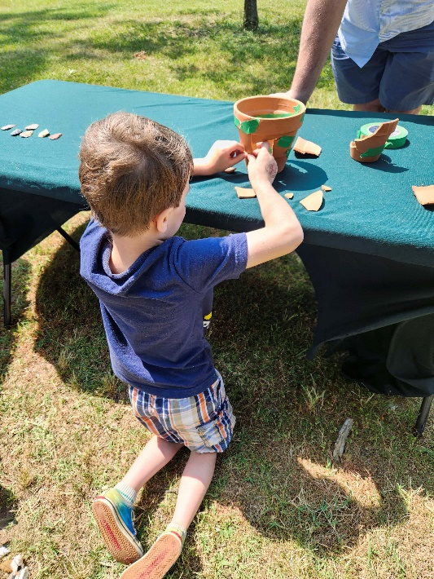

Photos by Pam Cressey

They also used screens to sift through the dirt and find smaller artifacts and could reassemble the broken pieces of pottery. Who knows – the park may have encouraged a budding archaeologist!
July Programs at
Mason Neck State Park
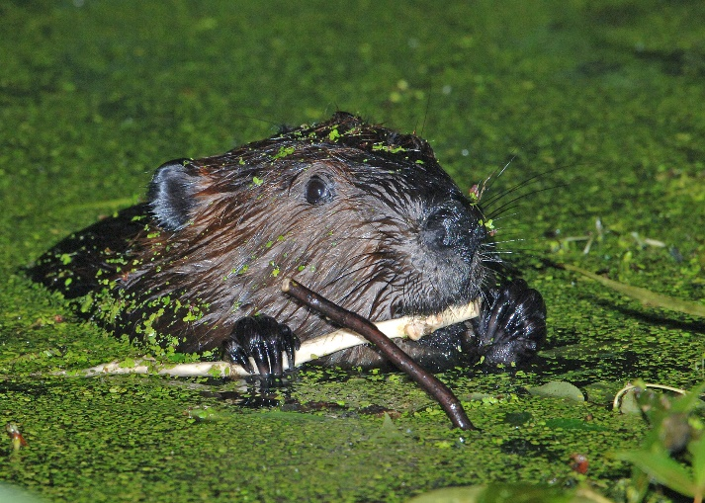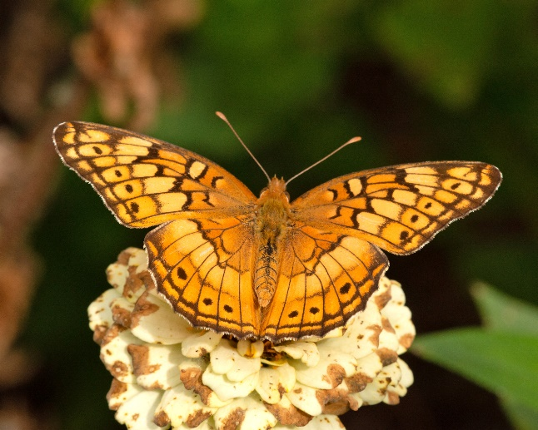
The Park has scheduled programs about beavers, snakes, owls, eagles, turtles, dragonflies, and more in July. You can learn about the events at the park in July on the park’s website. Just scroll down until you see the list of upcoming events and click on “More events at this park.”

Please Help Us Support
Mason Neck State Park!
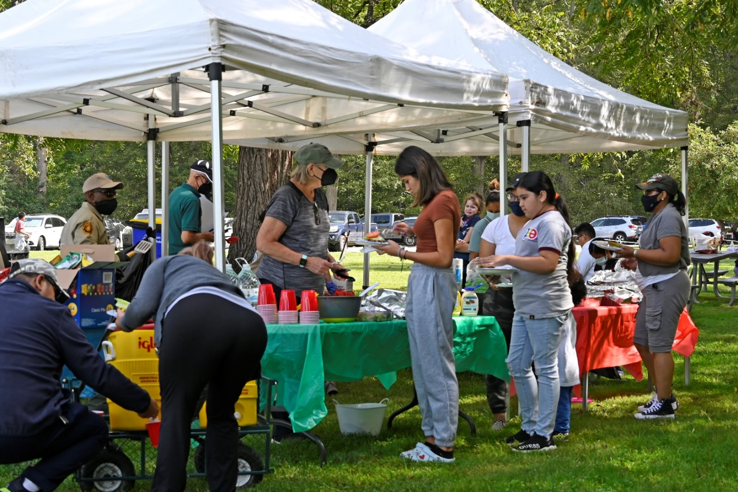

If you are already a member of the Friends of Mason Neck State Park, Thank You! Your membership dues and donations help us to support the Park, including funding initiatives that improve the accessibility of the park.
If you aren't a member, or your membership has lapsed, you can join the Friends here. You can also donate to the Friends here.

